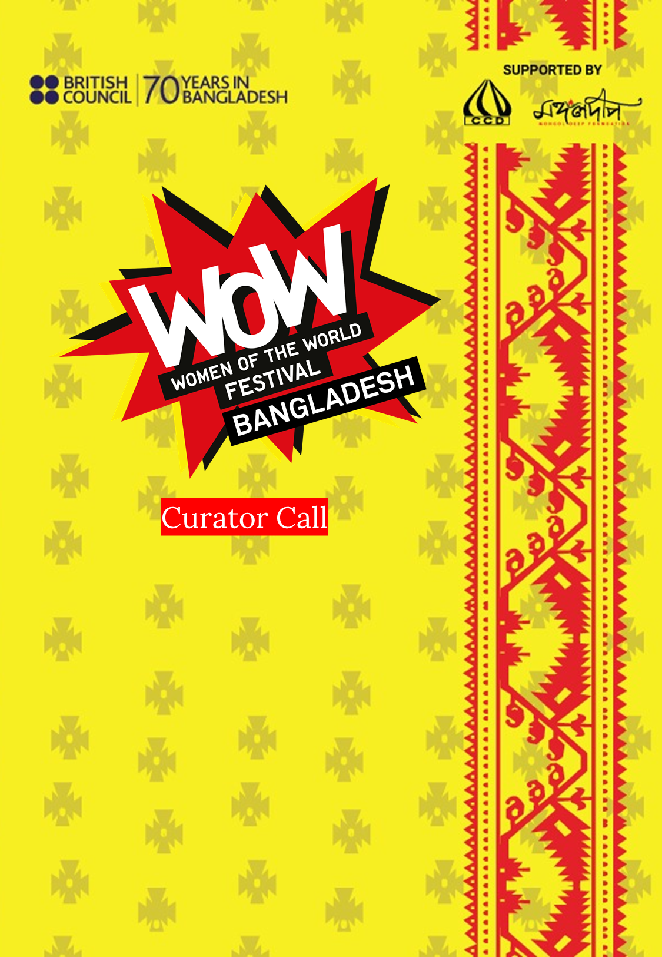
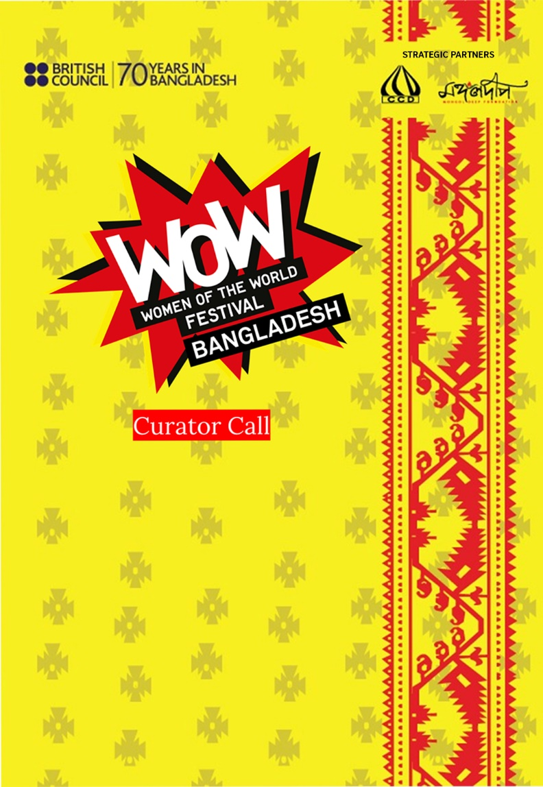
Part 1 – Curator’s Profile

For individual:
Name of the applicant
Name of the organisation/group(Optional)
Present address
Relevant work experience
Organisation name | Designation |  | Responsibility | Year

For organisation:
Name of the applicant
Name of the organisation/group
Present address
Relevant work experience
Title | Background |  | Event Detail | Year

1. Are you or your organisation a member of any relevant local or international network?
Network name | Your role | Duration

2. Do you have any experience of curating/organising programmes or events related to the theme of women and girls? Outline your involvement below.
Year | Title of event/activity | Number of people involved

3. What is your motivation for applying to curate Women of the World (WOW) Chapters in Bangladesh? Please mention your top three points only.

4. Please outline your proposed programme. The elements of the festival contain different activities, such as Panel discussions, WOW Bites (short talks, storytelling etc.), Pop-up performances, Music concert, Marketplace, Workshops and Speed mentoring. We anticipate WOW divisional Chapters that take place in Chittagong, Khulna, Rajshahi, Rangpur and Sylhet, to be a day long festival tentatively between January to March 2022. Successful curators will be working in coordination with WOW in Bangladesh strategic partners CCD Bangladesh, Mongol Deep Foundation and the British Council. All proposed activities must take Covid-19 related health and safety in consideration.
Part 2 – Programme Design
The previous WOW programmes in Bangladesh can be found here as a reference: https://www.britishcouncil.org.bd/en/wow-dhaka
Please clarify which divisional location you would like to focus on curating (one location or five locations).

WOW Elements  (Individual or All elements) | Proposed programme Location  (Mention name and number of location):
Essential
Panel discussions (one panel per location): Speakers are asked questions and moderated on a particular topic. These are generally hour-long sessions including questions and answers.  Please tell us about three discussion topics, relevant speakers as well as a moderator, whom you think will be suitable for the discussion. The topic should be trendy as well as relevant for a Bangladeshi audience.Kindly include brief profile of proposed moderator and speakers with examples.  Note: Per panel discussions budget ceiling limit BDT 1,00,000. CCD will lead the event. | Discussion Theme (in 100 words):  Moderator: Profile  Speaker 1: Profile  Speaker 2: Profile
Bites (up to three speakers per location): Sharing personal stories of women from diverse background. Each speaker is given 10 minutes to present their stories followed by a question and answer round.  Please tell us about five inspiring speakers whose profiles you think will be relevant for this segment along with the theme of their story.  Note: Three Bites budget ceiling limit BDT 30,000.CCD will lead the event. | Speaker 1 (theme):  Profile:

WOW Elements | Proposed programme
Pop-up Performance: Throughout the event, several engagement activities are held for the audience in the open air. Performances can include sports, exhibition performances, dance, installation etc.  Do you know an artist, organisation or a performer who would be appropriate for a performance or an exhibition? Tell us about his/her/their work that you would like to showcase. | Artist/Art Organization (Max 100 words):  Proposed activity (theme, execution method in Max 100 words):  Artist/Art Organization (Max 100 words):  Proposed activity (theme, execution method in Max 100 words):
Musical performance: Musical performances are held at the end of the event to conclude the program.  Please mention a woman-led band group or musician who can perform original music at the end of the day. In general, this is going to be an hour-long performance.  Note: Pop-up and Musical performance budget ceiling limit up to BDT 3,00,000. | Group/Individual Name:  Profile (Max 100 words):  Music Genre:

WOW Elements | Proposed programme
Marketplace(up to 10 stalls per location): This includes organisations/campaigns that are relevant to the cause of gender equality to set up stalls for selling products/services made by women (and/or for women).  Note: 10 Marketplace stalls budget ceiling limit up to BDT 70,000. | Stall 1:  Name and detail of the initiative (Max 100 words):
Workshop (up to one workshop per location): Hour long activities facilitated by an expert.  Please tell us three workshop themes and a facilitator’s name and profile who can deliver the workshop.  Note: One workshop budget ceiling limit up to BDT 50,000. | Workshop 1  Theme:  Facilitator:

WOW Elements | Proposed programme
Speed Mentoring (up to five mentors per location: Mentoring is the process whereby one person helps another to find her own solution to problems and difficulties connected with her work and career or personal life.  The aim of mentoring is to help the other person to:  - Clarify their goals and emotions  - Express tensions and frustrations  - Resolve problems effectively  - Further develop skills and confidence  Please provide the names and profiles of five mentors who could deliver the session as per the schedule.  Note: Five speed-mentoring budget ceiling limit up to BDT 60,000. | Mentor 1(Please focus on the theme):  Profile (Max 100 words)

Safeguarding
Through our work we meet many children and adults who are potentially at risk for a variety of reasons. We aim to create a safe environment in which no child or adult will experience harm or exploitation during their contact with us. Successful curators will need to comply with legislation and codes of practice, where applicable, relevant to the safeguarding and protection of children and vulnerable adults and with the British Council’s Child Protection Policy, as notified to the Curator.
More information: https://www.britishcouncil.org.bd/en/safeguarding

Part 3 – Budget
- Curators will need to propose a budget. This should include the cost of curating, commissioning, content design and materials, network promotion, any volunteers, any subsistence, transportation, all artist / speaker fees and any relevant taxes. Please note that this will not include venue rent, setup, stall making, digital campaign, advertisement and technical equipment for the festival as an agency will take care of this part. Budget ceilings for segments have been mentioned in Part 2: Programme Design.
Please use the sample budget excel spreadsheet to outline proposed budget breakdown
b) British Council Bangladesh expects curators to cover a portion of their curation costs. In addition, if you have any experience in developing partnership or sponsorship arrangements, we encourage curators to explore such opportunities for the delivery of WOW Festival.

In your view, specifically who can be a probable sponsor for your proposed activity? How much can he/she/they contribute? Please provide further details below for engaging him/her/them in this festival (200 words)

Part 4 – Campaign Idea
- Can you share your ideas of innovative and effective university campaigns which could be used to promote the WOW festival and its underlying messages in Bangladesh? (200words, bullet points preferred)

Selection Process
Applications will be reviewed by a selection panel led by the British Council, Mongol Deep Foundation and CCD Bangladesh. We aim to notify successful applicants by18 November 2021 for further discussion and presentation of their plans.
The weight distribution of the evaluation criteria will be as follows:
Area | Part | Weight
Programme design | Part 2 | 35%
Curator’s Profile | Part 1 | 20%
Budget | Part 3 (a) | 20%
Partnership and fundraising | Part 3 (b) | 15%
Campaign idea | Part 4 | 10%

For more information please visit the official website of Women of the World (WOW). You may also search online for different WOWs around the globe.
We will organise an online pre-briefing session on Wednesday, 10November 3.00 -4:30 PM where we will explain the application part by part.

ZOOM link: https://us02web.zoom.us/j/89203739543?pwd=U1V4UGpEMXpTcXJwbE91K0tHRWhHZz09
Meeting ID: 892 0373 9543
Passcode: 755030

If you have any further questions to better understand WOW in Bangladesh, please contact:

Mostafizur Rahman
Deputy Programme Manager
CCD Bangladesh
Tasib Palace, 418/1; MonaferMorhRajshahi- 6204, Bangladesh
M +880 1720 503767 T +880 258 886 7001
pm.ccdbd@gmail.com

About Women of the World (WOW)

Women of the World (WOW) is an international festival focused on women and girls across the world, that celebrates their achievements and looks at the obstacles they face throughout their journey. It includes talks, performances, activism, workshops, food, music, mentoring and much more. The vision of WOW is two-pronged: celebrating everything that women are doing to change the world for the better for everyone and taking a brave look at upholding gender equality in the future. By bringing people together it provides the inspiration and tools to make change happen.

Since 2017, five divisional chapters have been organized by British Council in Rangpur, Sylhet, Khulna, Rajshahi and Chattogram preceding the full-fledged national WOW festival Dhaka in 2019. As a response to Covid-19, Bangladesh and South Asian counterparts launched WOW Virtual, celebrating the festival online, and WOW Global 24, a 24-hour celebration around the world, and WOW Bangladesh Virtual Chapter.

At present, British Council, Mongol Deep Foundation and CCD Bangladesh are the strategic
partners for implementing WOW in Bangladesh.

To know more about WOW Festival, please visit:
https://www.britishcouncil.org.bd/en/wow-dhaka-2019-0
https://thewowfoundation.com/

About Mongol Deep Foundation
Mongol Deep is a foundation created with the objective to encourage all forms of cultural expression through theatre, poetry, dance, music or debates. It was officially formed in 2019 by a group of trustees with Sara Zaker being the chairperson. The organization operates with Ms. Zaker as the lead with active support from SriyaSharbojoya (MD Trustee) along with full support of a servicing & coordination team, a finance team and an HR and operations team. Mongol Deep was one of the curating partners for WOW Dhaka in 2019. It also partnered with British Council in launching WOW Virtual 2020 and WOW Global in 2021. During its collaboration with WOW, Mongol Deep nominated women in the field of science, the arts and environment who could represent Bangladesh on a global platform. This research will help bring the successes and challenges faced by women in Bangladesh to the forefront as well as opening up dialogues about gender equality.

About CCD Bangladesh
CCD Bangladesh is a non-profit, non-government knowledge centre that works with Communication and Journalism. It was established in 1999 at the northern region of Bangladesh. Since inception, it has been working with communication, media, culture and arts development in the grassroot level. It has been sincerely trying to ensure free flow of information, free press, free speech and free spirit of people. It promotes freedom of press, people's information empowerment, good governance, women empowerment, gender equality, youth leadership, cultural diversity, social justice, peace and tolerance in all levels.
The Chairperson of CCD is Mr. Waliur Rahman. G M Mourtoza is the Director and ShahanaParveen is the Joint director. CCD started working with WOW since 2018 as a partner, and curated WOW’s Rajshahi and Rangpur Chapters. It jointly curated WOW Bangladesh which was held at Dhaka, in 2019. CCD has successfully curated six divisional ‘ThinkIn’ programs for this year and has been involved in the launch of WOW Digital 2020 and WOW Global 2021. CCD Bangladesh will join British Council and Mongol Deep in the advisory panel for final selection of the researcher.

About the British Council
The British Council is the UK’s international organization for cultural relations and educational opportunities. We create friendly knowledge and understanding between the people of the UK and other countries. We do this by making a positive contribution to the UK and the countries we work with – changing lives by creating opportunities, building connections and engendering trust. Founded in 1934, we are a UK charity governed by Royal Charter and a UK public body. The British Council employs over 10,500 staff worldwide. It has its headquarters in the UK, with offices in London, Manchester, Belfast, Cardiff and Edinburgh.

With festivals taking place all over the world, WOW has also been a driving force in South Asia in raising awareness across the region about the barriers preventing women and girls reaching their full potential. With collaboration and participation between countries like Bangladesh, Nepal, Pakistan, and Sri Lanka, British Council is committed to amplifying voices of women and girls across South Asia, providing skill development resources, representing leaders from different fields, and creating a network of women leaders to advance equality for women in the region. Further information can be viewed at www.britishcouncil.org

